*Please join Chatham University’s Education department as they welcome*

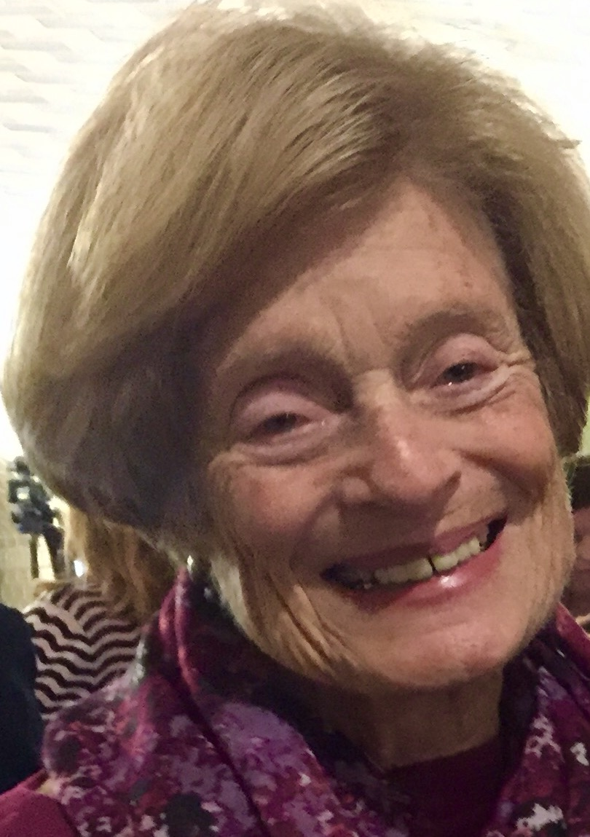

Dr. Susan Uchitelle

*"Lessons learned from Desegregation Programs that apply to all Students and Teachers."*

January 17, 2017 at 5pm

Welker Hall

Chatham University